Week 2 Activity: Obtaining and Scrubbing Data
Anna owns a clothing boutique in New York, called BrightThreads. She sells a mix of clothing brands and chooses items for her store that she believes her clients will like. She also sells online.

Anna is working on long-term planning for the upcoming year at BrightThreads. Business has been going well, but she would really like to increase sales and potentially open up a second location in a different neighborhood. Next year, Anna would like to increase her total sales by 10%. This would be a very good year for Anna and BrightThreads, but it seems doable based on the last few quarters and with some hard work.

Using this information, answer the questions below regarding the obtain and scrub stages of the OSEMN process. Add your answers to the template below.

In this scenario, what is a SMART goal that would benefit from data analysis?

Increase BrightThreads’ total sales by 10% over the next year by analyzing customer purchase trends and identifying best-selling product categories.

What is a Primary KPI that would be useful to analyze for this goal?

Total monthly sales revenue (or average sales per customer).
This KPI directly measures progress toward the 10% sales growth goal.

What relevant data would you gather in this scenario?

Historical sales data (in-store and online)
Customer demographics (age, location, gender)
Product categories and pricing
Website traffic and conversion rates
Seasonal sales trends

How do you imagine you could obtain this data? What sources would you gather data from? Specifically, note what kind of data (first-party, third-party) and what methods you might use (survey, web analytics).

- First-party data: Collected directly from BrightThreads’ POS system and online store analytics (e.g., Google Analytics, sales database).
- Third-party data: Market trend reports or industry benchmarking data from research firms.
- Methods: Web analytics tools, customer surveys, and internal sales reports.

Anna at BrightThreads has begun the process of gathering data to help analyze current sales.

She has collected data on recent online sales directly from the online storefront.

Access this sample Customer Data and click on Use Template in the upper right corner. You will need to be logged into a Google account to use this template.

Anna has isolated 4 different segments that each have issues that need to be fixed. You can access each segment in the four sheets in this one spreadsheet. Click on each sheet for a different segment of the dataset. You can click on the tabs at the bottom of the spreadsheet to move between sheets. Review the image below for a preview:
The four sheets are accessible by clicking the tabs at the bottom of the spreadsheet.

Using what you know about data validity, do you think the data Anna has gathered is valid? Why or why not?

Yes, the data Anna collected appears valid because it comes directly from BrightThreads’ online sales system (first-party data). It includes relevant fields such as customer ID, order number, ZIP code, item category, and item cost — all of which are necessary for sales analysis. However, data validity could still be improved by checking for missing ZIP codes, incorrect or inconsistent item categories, and ensuring that all item costs are in the same currency and format.

What issue did you identify in segment 1 of the data?

Possible issue: Duplicate records.
Example: Some customer IDs or order numbers may appear more than once, which can lead to inflated sales totals or inaccurate customer counts.

What issue did you identify in segment 2 of the data?

Possible issue: Inconsistent ZIP code formats or missing data.
Example: Some ZIP codes may be missing digits or not follow the same format (e.g., 21098 vs. 021098). This inconsistency can affect location-based analysis..

What issue did you identify in segment 3 of the data?

Possible issue: Inconsistent item categories.
Example: Some entries might use different terms for the same category (e.g., “Tops” vs. “Shirts”) or have spelling errors. Standardizing these labels is important for grouping and comparison.

What issue did you identify in segment 4 of the data?

Possible issue: Incorrect or missing numerical values in the “item_cost” column.
Example: Some costs may be missing, listed as text instead of numbers, or contain formatting errors (e.g., “$49.99” vs. “49.99”).

Week 3 Activity: Exploring and Modeling Data
Anna from BrightThreads is exploring some data from last quarter's online sales.

The data was gathered from the BrightThreads online store.

Access BrightThread’s online sales data and click on Use Template in the upper right corner to access the dataset. Please note you will need to be logged into a Google account.

Review the following data and charts, then share what you can learn in the exploration stage of the OSEMN process.

Using this information, answer the questions below regarding the explore and model stages of the OSEMN process. Add your answers to the template below.

What are some things you can tell about this dataset? For instance, what does the size of the dataset tell you?

This dataset contains 58 rows and 7 columns, representing individual online sales transactions from BrightThreads’ store. The dataset is moderately small, making it easy to explore and visualize. It includes customer, order, and item information, which can help identify purchasing patterns and sales trends.

What kind of data is in this dataset? (Numerical, categorical, etc.)

Numerical data: quant_items_per_order, order_total, zip_code
Categorical data: item_category
Date/time data: sale_date
This mix of data types allows both quantitative and qualitative analysis of customer behaviour.

Reviewing this data, what is the minimum value in the order_total column? What is the maximum value in order_total column?

- Minimum order total: $39.99
- Maximum order total: $149.99
This range suggests that most BrightThreads purchases fall between $40 and $150.

What kind of chart would you use to help visualize this data?

A histogram or bar chart is ideal to visualize the distribution of order totals. It helps identify which price ranges have the most orders and whether the data is skewed toward higher or lower purchase amounts.

Based on what you have learned, would you add an additional column to this dataset using feature engineering? For instance, using the sales dates, would it be helpful to add in the day of the week data?

Yes. A useful new feature would be the day of the week or month extracted from sale_date. This would help identify time-based sales trends—such as whether customers purchase more on weekends or during specific months.

Anna has created the following chart to explore the relationship between order totals and the number of orders.

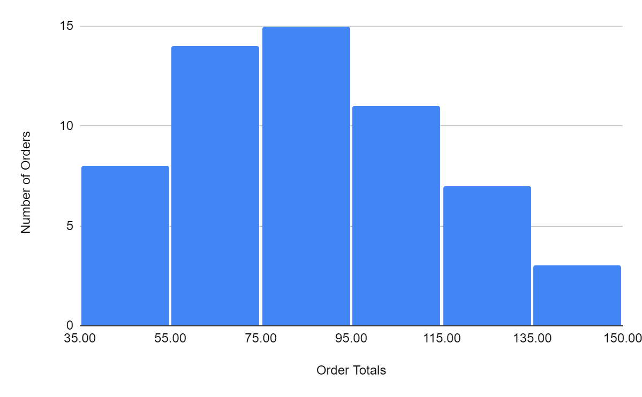
Based on the data in this chart, what would be a good title for this chart?

“Distribution of Order Totals for BrightThreads Online Sales”

What does this chart tell you about the number of orders in relation to the amount someone spends per order?

The chart shows that most orders fall in the mid-range spending category (around $70–$100). Fewer customers make very low or very high-value purchases, indicating that mid-range items are the most popular.

What range do most of the orders tend to be in?

Most orders tend to be between $65.99 and $100.99, suggesting this is the store’s typical spending range.

Anna has also been analyzing data on the amount of money she spends on social media ads and how many clicks to the BrightThreads website they are generating.

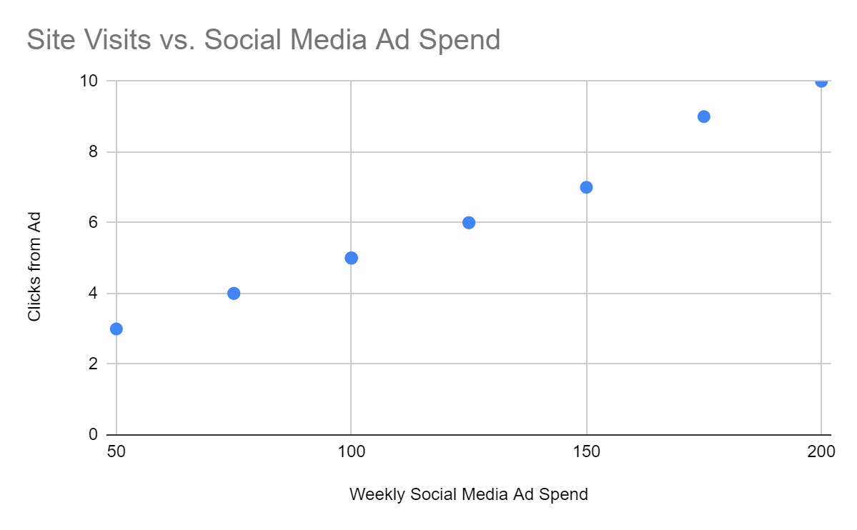
Do you notice any correlations between the variables in this chart? If so, how would you describe them?

Yes. There is a strong positive correlation between social media ad spend and site visits. As the ad spend increases, the number of site visits also rises almost proportionally, suggesting the marketing budget directly influences customer engagement.

Anna has learned a lot while exploring the data she has gathered. Now, it’s time to model some of this data.

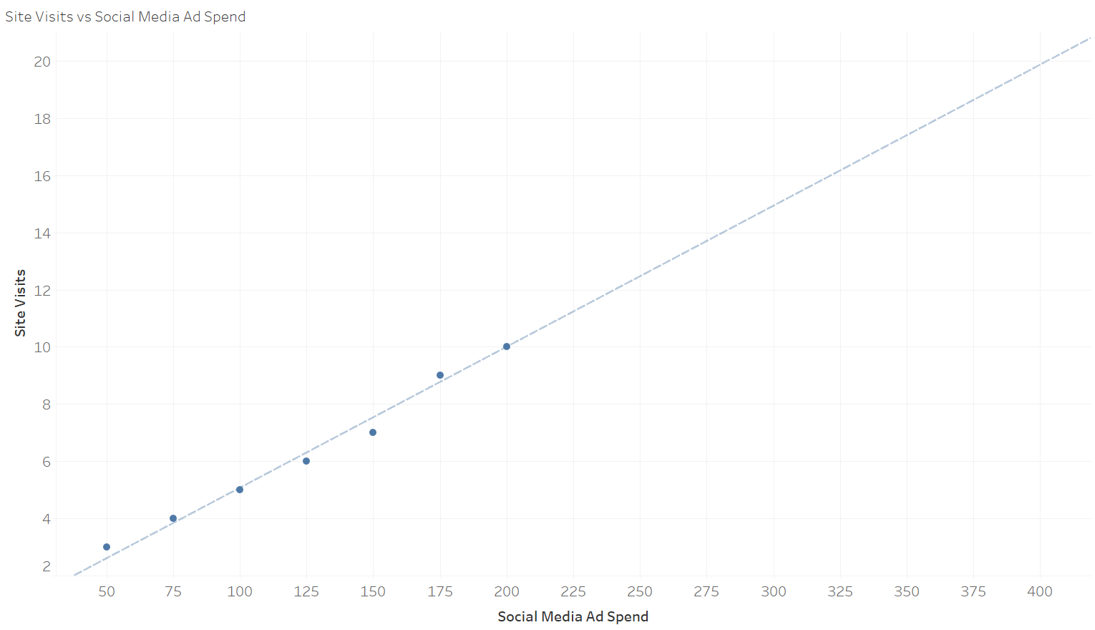
Reviewing this linear regression model, roughly how many site visits can be expected if the marketing budget is increased to $250?

Based on the regression line, if the marketing budget increases to $250, the number of site visits is expected to be approximately 12–13 visits.

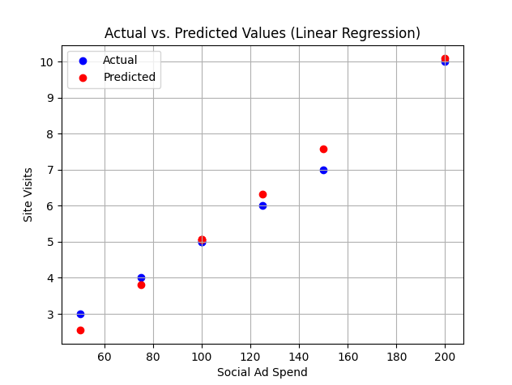

Review this linear regression model which shows the actual data values and the values predicted by the model when given a test set. Do you think that this model is sufficient for general use for this data? Why or why not?
Yes, this model appears sufficient for general use because the predicted points closely follow the actual data trend, indicating a good fit. However, since the dataset is small and limited to one quarter, additional data from other periods would help confirm the model’s accuracy and reliability.

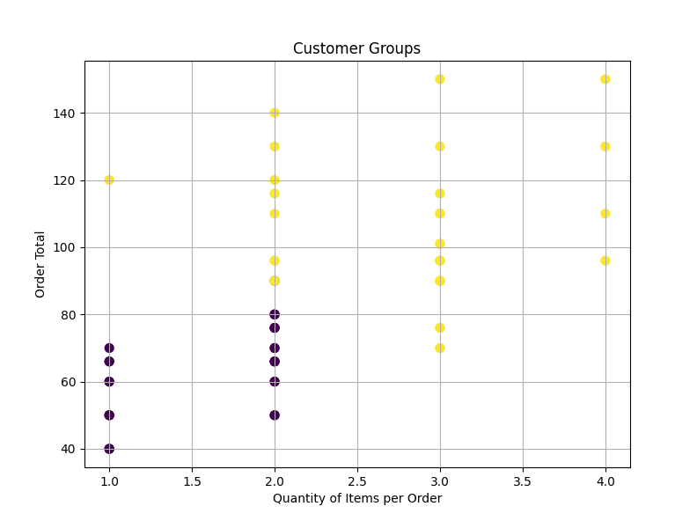

Review this clustering model. A clustering algorithm has been used and identified two groups. How would you describe the two different customer groups? Why?

The two clusters likely represent:
- Group 1: Customers with small orders (1–2 items, lower order totals) — occasional or new buyers.
- Group 2: Customers with larger orders (3–4 items, higher order totals) — frequent or high-value buyers.
This distinction can help the company tailor marketing strategies for each group (e.g., loyalty rewards for frequent buyers).

You are trying to forecast BrightThreads sales in the coming quarter- what model might you use? Why did you choose this?

A time series forecasting model (such as ARIMA or linear regression over time) would be most suitable. This model accounts for trends and seasonality in sales over time, making it useful for predicting future sales based on past performance.

Week 4 Activity: iNterpreting Data
Anna has learned many things using data analysis. She has prepared a presentation to show to BrightThreads stakeholders. As a reminder, her goal is to grow sales by 10% in the upcoming year, and this presentation will cover what she’s learned and how she plans to accomplish this goal.

Access Anna’s presentation.

Review the presentation, then share your thoughts on Anna’s interpretation of the data at the end of OSEMN process.

Using this information, answer the questions below regarding the interpret stage of the OSEMN process. Add your answers to the template below.

What was the objective for this analysis?

The objective of the analysis was to determine how BrightThreads could increase overall sales by 10% in the upcoming year by analyzing past sales data, customer preferences, and marketing performance.

How does the date answer Anna’s questions?

The data showed that:
- Small adjustments, such as focusing on best-selling items, can noticeably increase sales.
- Reallocating advertising spend toward higher-performing social media channels can improve site visits and engagement.
- Predictive models confirm that a 10% increase in sales is achievable with these strategies.

How can Anna apply this in a business context?

Anna can use these insights to:

Adjust inventory toward high-demand items.

Optimize marketing budgets to focus on top-performing channels.

Track KPIs like monthly sales growth and ad ROI to monitor progress toward the 10% target.

What slides in the presentation shared the recap of the project?

Slides:
- “BrightThreads Goals”
- “Project Objectives”
These summarize the company’s goals and what the analysis aimed to achieve.

What slides in the presentation covered the methods used in the project?

Slide:
- “Methods For Analysis”
This explains the goal, story, audience, and tools used for data analysis (historical sales data, categorical and time analysis, and predictive models).

What slides in the presentation included visualization of the project?

Slides:
- “This chart shows our sales numbers for the last two years”
- “This model shows how much we’ll need to sell each quarter…”
- “This chart shows our current top-selling items”
- “This model shows our potential sales increases…”
- “This chart shows our current spending on social media advertising…”
These slides visualize sales trends, item performance, and marketing results.

What slides in the presentation provided an explanation of the project?

Slides:
- “What The Data Shows”
- “Moving Forward”
They explain what insights were drawn and what actions BrightThreads should take next.

What slides in the presentation offered recommendations after the project?

Slide:
- “Moving Forward”
It recommends reallocating ad spend, refining inventory, and reevaluating results in six months.

In your opinion, what parts of the presentation were meant to explain, engage, and enlighten the audience? Why?

- Explain: “Project Objectives” and “Methods for Analysis” — they clarify purpose and process.
- Engage: Visual slides showing sales trends and item performance — they help the audience visualize data impact.
- Enlighten: “What The Data Shows” and “Moving Forward” — they provide insights and actionable next steps.

In your opinion, what parts of the presentation were the setup, buildup, climax, and conclusion? Why?

- Setup: “BrightThreads Goals” — introduces the challenge and objectives.
- Buildup: “Data We Analysed” and “Methods for Analysis” — explains how the data was approached.
- Climax: Visuals and models showing potential growth and marketing impact — main findings are revealed.
- Conclusion: “What The Data Shows” and “Moving Forward” — summarize key insights and call to action.

